Project Design Phase-II
Technology Stack (Architecture & Stack)

Date | 31 January 3035
Team ID
Project Name
Maximum Marks | 4 Marks

Technical Architecture:
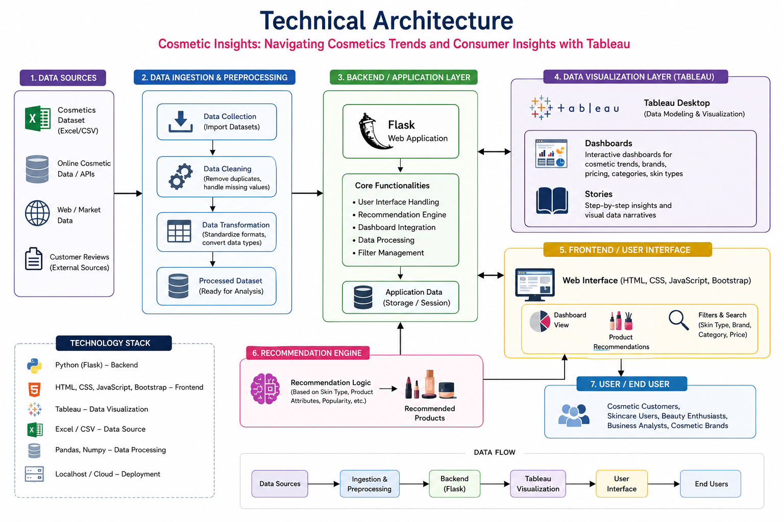

Table-1 : Components & Technologies:
S.No | Component | Description | Technology
 | User Interface | Web application for users to explore dashboards, stories, and recommendations. | HTML, CSS, JavaScript.
 | Application Logic-1 | Product recommendation based on skin type | Python
 | Application Logic-2 | Data processing and filtering of cosmetic dataset | Python
 | Application Logic-3 | Dashboard and Story integration | Tableau Public Embedded API
 | Database | Stores cosmetic product information and recommendations | CSV Dataset / Pandas DataFrame
 | Cloud Database | Not used in current implementation | N/A
 | File Storage | Storage of dataset, images, and static files | Local File System
 | External API-1 | Tableau Dashboard Embedding | Tableau Public
 | External API-2 | Cosmetic Dataset | Kaggle Dataset
 | Machine Learning Model | Rule-based recommendation system based on skin type | Python Recommendation Logi
 | Infrastructure (Server / Cloud) | Web application hosting and deployment | Render Cloud Platform

Table-2: Application Characteristics:
S.No | Characteristics | Description | Technology
 | Open-Source Frameworks | Frameworks used for web application development and analysis | Flask, Pandas, Bootstrap, Tableau Public
 | Security Implementations | Basic input validation and secure deployment practices. | Flask Validation, HTTPS (Render)
 | Scalable Architecture | Modular architecture separating UI, recommendation logic, and visualization | Flask Three-Tier Architecture
 | Availability | Cloud deployment ensures application accessibility from anywhere | Render Cloud Hosting
 | Performance | Fast filtering and recommendation generation using optimized dataset processing | Tableau Visualization

